Multi-Modal Intelligent Traffic Signal System
System Design
University of Arizona (Lead)
University of California PATH Program
Savari Networks, Inc.
SCSC
Econolite

Version 1.0

5/25/2013

RECORD OF CHANGES
A – Added, M- Modified, D - Deleted

Version Number | Date | Identification of Figure, Table, or Paragraph | Title or Brief Description | Change Request Number
1.0 | 2/8/2013 | N/A | Initial Draft for Team Review/Development
1.1 | 5/25/2013 |  | Completion of the Software Component descriptions.
2.0 | 6/26/2013 |  | Modifications in response to Panel review comments

1 Purpose of Document 5
2 Scope of Project 5
3 Selected Use Cases for System Development 5
4 System Design 7
4.1 Physical Architecture 7
4.1.1 MMITSS Roadside Processor 9
4.1.2 RSE Radio 10
4.2 Software Components 10
4.2.1 Components 12
4.2.2 Artifacts 20
5 Appendices 21
5.1 Acronyms 21
5.2 Appendix A: Savari and Arada RSE Product Specification Sheets 23
5.3 Appendix A: Savari OBE Product Specification Sheets 29

List of Figures
Figure 4-1. MMITSS Physical Architecture. 8
Figure 4-2. MMITSS Software Components 11

List of Tables
Table 3-1. Summary of Down Selected Use Cases for Implementation 5

Purpose of Document
This document contains the high level system and software design for the Multi-Modal Intelligent Traffic Signal Systems (MMITSS). The approach taken to the design has been to create a high level component based design that ensures all of the requirements are addressed by one or more components. The component based design approach supports both reuse and customization in the software implementation. Each component can be developed by the best suited team member such that they can use any desired detailed design approach available to them and define the interfaces that enable communications with other components. Custom components can be developed where needed, such as at the controller interface that is different in California and in Arizona. The common components can be reused in each test network.

Scope of Project
The Multi-Modal Intelligent Traffic Signal System (MMITSS) project is part of the Cooperative Transportation System Pooled Fund Study (CTS PFS) entitled “Program to Support the Development and Deployment of Cooperative Transportation System Applications.” The CTS PFS was developed by a group of state and local transportation agencies and the Federal Highway Administration (FHWA). The Virginia Department of Transportation (VDOT) serves as the lead agency and is assisted by the University of Virginia’s Center for Transportation Studies, which serves as the technical and administrative lead for the PFS.
The United States Department of Transportation (US DOT) has identified ten high-priority mobility applications under the Dynamic Mobility Applications (DMA) program for the connected vehicle environment where high-fidelity data from vehicles, infrastructure, pedestrians, etc. can be shared through wireless communications. Three of the applications (Intelligent Traffic Signal System, Transit Signal Priority, and Mobile Accessible Pedestrian Signal System) are related to transformative traffic signal operations. Since a major focus of the CTS PFS members – who are the actual owners and operators of transportation infrastructure – lies in traffic signal related applications, the CTS PFS team is leading the project entitled “Multi-Modal Intelligent Traffic Signal System” in cooperation with US DOT’s Dynamic Mobility Applications Program.
The MMITSS project is divided into four technical segments. The development of the ConOps, including the solicitation of Stakeholder inputs and feedback, was the first technical stage. The reviewed Stakeholder inputs and ConOps were used to develop, define, and populate the MMITSS system requirements in the second technical stage. In the third stage, the system requirements and prior research were used to define the MMITSS system design. The design effort will utilize the California Test Bed and the Maricopa County Test Bed as the target implementation networks. Implementation, integration, deployment, and test plans based on this design will be defined in the final stage

Selected Use Cases for System Development
The Concept of Operations and Systems Requirements Documents developed and identified use cases, functional, and performance requirements that characterize the desired behaviors of MMITSS. Table 3-1 summarizes the use cases that were considered the development of the Concept of Operations. These use cases have been reviewed to determine which should be included in the Phase II development and demonstration scope.
Table 3-1. Summary of Down Selected Use Cases for Implementation
 | Operational Scenarios/Use Cases | Include | Defer | AZ | CA
11 | MMITSS Operational Scenario
11.0.1 | Network Section 1 | X |  | X
11.0.2 | Network Section 2 | X |  |  | X
11.1 | Intelligent Traffic Signal System Scenarios
11.1.1 | Basic Signal Actuation | X |  | X | X
11.1.2 | Coordinated Section of Signals | X |  | X | X
11.1.3 | Congestion Control |  | X
11.1.4 | Dilemma Zone Protection | X |  | X | X
11.2 | TSP Operational Scenarios
11.2.1 | Basic TSP Scenario and Variations | X |  | X | X
 | Nearside Bus Stop |  | X
 | Transit Signal Priority for Left Turn with Protected Signal |  | X
11.2.2 | Operational Scenarios for Rail Crossings in Urban Areas |  | X
11.2.3 | Extended TSP Scenario | X |  | X | X
11.3 | Pedestrian Mobility Operational Scenarios
11.3.1 | Unequipped Non-Motorized Traveler | -
11.3.2 | Equipped Non-Motorized Traveler | X |  | X | X
11.3.3 | Equipped Bicyclist |  | X
11.3.4 | Inclement Weather Accommodations for Non-Motorized Travelers |  | X
11.4 | Freight Signal Priority Operational Scenarios
11.4.1 | Basic Freight Signal Priority | X |  | X | X
11.4.2 | Coordinated Freight Signal Priority along a Truck Arterial | X |  | X | X
11.5 | Emergency Vehicle Priority
11.5.1 | Single Intersection Priority/Preemptions | X |  | X
11.5.2 | Route Based Intersection Priority/Preemption |  | X

The review of the use cases considered several factors in selecting a fundamental set for inclusion in the design and development effort (Phase II). The factors include: 1) importance to the demonstration of the MMITSS concept, 2) feasibility to validate the requirements associated with each use case, 3) technical feasibility to develop system components to achieve the desired behaviors given the resources available, and 4) the strengths of the Arizona and California Testbeds in terms of transit, pedestrians, freight, and emergency vehicles.
Use Cases 11.0.1 and 11.0.2 represent the highest-level goal of MMITSS. That is, to establish a multi-modal operating policy that provides service to all modes of travel, but provides priority to one or more modes. For example, Use Case 11.0.1 represents a corridor where freight is favored over transit and pedestrians. Use Case 11.0.2 represents a corridor where transit and pedestrians are favored over freight. Emergency vehicles receive priority over all modes in both Use Cases. Arizona was selected for Use Case 11.0.1 since there is no transit service provided in the network (but transit service can be demonstrated using simulated buses). The California testbed was selected for Use Case 11.0.2 since there is transit service (but freight could be simulated if needed).
Use Cases 11.1.1 (Basic Signal Actuation), 11.1.2 (Coordination of Signals) and 11.1.4 (Dilemma Zone Protection) were selected since they represent the core traffic signal operation Use Cases. 11.1.2 (Coordination of Signals) represents the goal of having MMITSS provide some form of optimizing signal control. 11.1.1 and 11.1.4 represent the key benefit of being able to track the trajectory of equipped vehicles as they approach an intersection.
Note that the Congestion Control, Use Case (11.1.3) includes the use of queue length estimation to terminate a phase that is feeding an oversaturated movement. Other Congestion Control strategies include reverting to free operation at a congested intersection, and adjustment of the cycle length, splits and/or phase sequence to coordinate upstream signals to control flow into the congested intersection/movement. This Use Case was not selected based on the need for a sufficient network penetration rate of equipped vehicles (e.g. passenger vehicles) in the network to allow accurate traffic state estimation. This penetration rate is not feasible to achieve within the scope and budget available for Phase II of this project.
The Use Cases associated with priority control (11.2, 11.4, and 11.5), including transit, freight, and emergency vehicles, were selected since they represent core MMITSS functionality. All of these Use Cases utilize the same underlying behavior (e.g. a vehicle sends a request for priority and the infrastructure determines how priority can be accommodated). Only the basic Transit Priority (TSP) and extended TSP Use Cases (11.2.1 and 11.2.3) were included. Special behaviors for near side bus stops, protected left turn priority, and railroad crossings were excluded. Route based priority, or coordinated corridor priority, for each transit and freight was included despite some concerns about having route information available. It was assumed that the route information was available for transit routes and assumed known for freight corridor coordination, and not available for emergency vehicles.
Pedestrian Mobility (Use Case 11.3) was included due to the importance to MMITSS, the feasibility to validate the requirements, and the technical feasibility of implementation. Pedestrian Mobility is a significant opportunity for MMITSS to demonstrate the modal interactions. The underlying mechanism of Pedestrian Mobility is similar to Transit, Freight, and Emergency Vehicles priority, except it requires and utilizes non-DSRC nomadic devices. This is an important capability of MMITSS that may have wider implications for large scale deployment in the future.

System Design
The high level system design is defined by the physical and software components.

Physical Architecture
The Physical MMITSS architecture is shown in Figure 4-1 as a UML Deployment Diagram. This architecture is based on the Conceptual Architecture identified in the MMITSS Concept of Operations and MMITSS Systems Requirements documents. In the Unified Modeling Language (UML), nodes are shown as 3D blocks and represent physical devices that have a processor (at least one), memory, and physical interfaces (e.g. Ethernet, RS-232, or wireless – 3G/4G, 5.9GHz DSRC, or other such as CAN-bus).
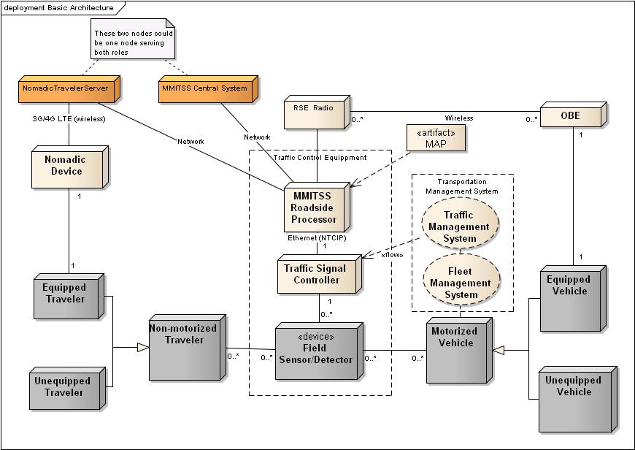
Figure 4-1. MMITSS Physical Architecture.
The nodes have been shaded such that the light colored nodes are part of the connected vehicle system, Traffic Management and Fleet Management systems (or nodes that can be modified or assigned MMITSS responsibilities) and the gray colored nodes represent the vehicles and travelers. The orange colored nodes are the MMITSS Central System and Nomadic Traveler Server as described below. These two nodes may be realized as a single node for the testbed implementations.
In this view of the system, there are two types of travelers – motorized vehicles and non-motorized travelers. Motorized vehicles consist of passenger vehicles, trucks, transit vehicles, emergency vehicles, and motorcycles. This type of traveler includes any vehicle that must be licensed to operate on the public roadway. Non-motorized travelers include pedestrians, bicyclists, and other modes such as equestrians that are not required to be licensed to operate on the public roadway. These travelers are either unequipped or equipped, meaning that they have some type of OBE (On-Board Equipment) or nomadic device that is connected vehicle (or MMITSS) aware and can operate as part of the traffic control system.
Motorized vehicles can be part of a fleet management system such as a transit management system, commercial freight management system, emergency vehicle dispatch system, and taxi dispatch, which is shown as a UML collaboration (oval in Figure 4-1) meaning that a collection of entities work together to perform the traffic management functions, but there may be many different systems involved in this collaboration.
The infrastructure based traffic signal control equipment consists of the traffic signal controller, field sensors/detectors, and a MMITSS Roadside Processor (MRP). There are two traffic signal controllers models that will be utilized in the field installation: Econolite ASC/3 (NTCIP) (AZ) and Type 2070 (Caltrans – AB3418) (CA). Each of these controllers offers different signal timing logic (software) and require different communications interfaces. The Econolite ASC/3 controllers are based on NEMA standards and support NTCIP over Ethernet communications. The Caltrans Type 2070 controllers are based on a Caltrans standard and support AB3418 over serial RS-232 communications. Both networks utilize loop detectors for vehicle detection. The MMITSS Roadside Processor was included in the architecture to allow the RSE to provide a pure communications role in the systems. The MRP is a Linux based general-purpose computer (see Section 4.1.1 below for details).
The RSE Radio is the hardware device that is responsible for managing all of the 5.9GHz DSRC communications between the vehicles and the infrastructure. The Arizona network utilizes Savari RSE units. The California utilizes both Savari and Arada RSE units. (see Section 4.1.2 below for details).
The OBE is a hardware device deployed on the vehicle. MMITSS will be developed and tested using Savari MobilWave units for the OBE. These units are general purpose and provide a powerful and flexible platform for development and testing. The product data sheet for the OBE is in Appendix A: Savari OBE Product Specification Sheets.
The larger traffic management system is shown as a UML collaboration in Figure 4-1. The RSE is a general communications processing node that coordinates messages from the various modes of travelers. The MMITSS Roadside Processor (MRP) is a general purpose computer that hosts the core intersection level infrastructure applications for MMITSS. The RSE contains (deploys) the MAP artifact, which is the digital description of the intersection geometry and associated traffic control definitions.
Both motorized and non-motorized travelers can be detected by the Field Sensor/Detector node at the intersections using a variety of detection technologies, including inductive loop detectors, video detection, microwave, radar, pedestrian push button, etc. The detection system at an intersection provides information to the traffic signal controller that stimulates the control algorithms. For example, a vehicle that triggers a detector will call a signal control phase for service or extension. A pedestrian may activate a pedestrian push button to request the traffic signal pedestrian interval associated with a crosswalk movement.
Each of the systems that can be active participants in the MMITSS (e.g., connected vehicle, Traffic Management, and Fleet Management) can have different responsibilities, and in alternative system designs some of these responsibilities can be assigned to different components. In the discussion presented here, the basic operating functions will be reviewed and the alternative assignments will be explored in the detail design effort.

MMITSS Roadside Processor

The MMITSS Roadside Processor (MRP) selected for the California test network is described by the following specification:

Jetway NF9E-Q77 Mini-ITX Motherboard, Q77 Express vPro iAMT, LGA1155, Ivy Bridge
Enclosure, power supply: Super Case MI-100BK Mini-ITX Case
Digital I/O board: PCIe-IIRO-8
CPU chipset, fan: Intel Core i5-3570 Ivy Bridge 3.4GHz (3.8GHz Turbo Boost) LGA 1155 77W Quad-Core Desktop Processor Intel HD Graphics 2500 BX80637i53570
Disk drive: Seagate Constellation ES ST500NM0011 500GB 7200 RPM 64MB Cache SATA 6.0Gb/s 3.5" Enterprise Internal Hard Drive -Bare Drive
System memory: Transcend 8GB (2 x 4GB) 240-Pin DDR3 SDRAM DDR3 1333 Desktop Memory Model JM1333KLN-8GK
Operating System: Ubuntu Server 12.04.2 LTS

These components will be assembled into a field deployable roadside device. [Note: this processor is planned for deployment in the California testbed. The temperature range of these units has a maximum range of 140F. There is some concern about the use of this design in the Arizona testbed].

RSE Radio
Two RSE Radios have been selected for this project: Savari Streetwave (3.1) and Arada LocoMate. The Arizona testbed uses the Savari units. The California testbed used both Savari and Arada units. Both units support two 5.9GHz DSRC radios and an Ethernet interface for communications. The product spec sheets are available in Appendix A: Savari and Arada RSE Product Specification Sheets.

Software Components
Figure 4-2 shows the primary software components of MMITSS. The software is grouped according to the deployment nodes. The OBE (on-board equipment) is deployed on each equipped vehicle. The OBE_name software components provide the functionality required of the OBE. The OBE communicates with the RSE (roadside equipment) over the DSRC WAVE channel. The RSE_name software components provide the key wireless communication behaviors including sending and receiving messages, as well as the Service Advertisement and Security Certificate services. The MMITSS Roadside Processor communicates with the RSE using local Ethernet network, and with the MMITSS Central System and the Nomadic Traveler Service using a combination of field and backhaul communications. In the Marcopa County SMARTDrive network a fiber optic local network is provided between all of the test intersections and a wireless backhaul connection is provided from the field to the MCDOT traffic operations center (TOC). In the California Test Network, field communications is managed through a field master that communicates with each intersection controller over multi-drop serial communications. The field master has backbone access to the traffic operations center. The MMITSS Roadside Processor also communicates to the intersection traffic signal controller. The MMITSS Roadside Processor hosts software components that perform the core intersection level functions of MMITSS. These components include the MAP and SPaT broadcast manager, the equipped vehicle tracker, the priority request server, traffic control logic, the interface to the traffic signal controller (AB3418 or NTCIP), and the components that communicate status to the Nomadic Traveler Service including status and nomadic device tracking. The MMITSS Roadside Processor also hosts the performance observer component.

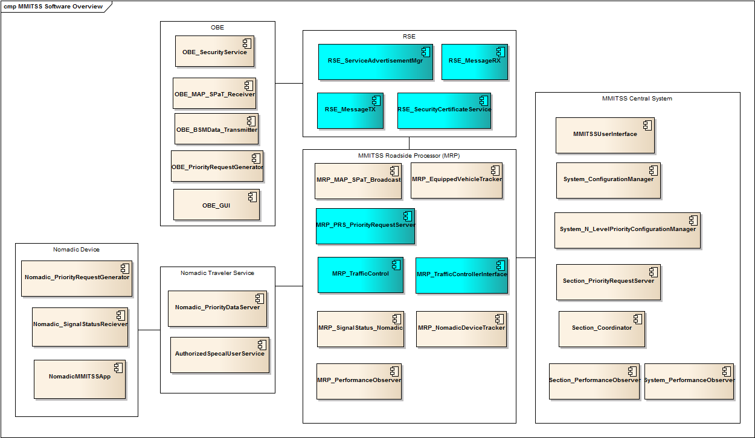
Figure 4-2. MMITSS Software Components

The MMITSS Central system hosts software components that provide a user interface, configuration manager, N-level priority policy configuration manager, and section level priority server and signal coordination. The MMITSS Central system also hosts the section and system level performance observers.
The Nomadic Traveler Service hosts two software components that provide the priority data service that relays intersection data (e.g. MAP and SPaT data) to nomadic devices and receives requests for service/priority from nomadic devices. The Nomadic Traveler Service also hosts the security and authorization service for nomadic devices that ensures these devices are associated with valid users and are authorized to receive special service if the user is a disabled pedestrian.
The Nomadic device is assumed to be a smart phone, either ios or Android based, and hosts an applications (app) that uses two components. One component requests service/priority and the other collects and makes status information available for display on the app.

Components
This section contains a summary of each of the software components in terms of their responsibility as defined by the associated requirements and description in the concept of operations document. Each component is given a name, traceability information to requirements, concept of operations, and/or stakeholder requirements, a brief description of the components responsibility, and any additional text useful for understanding the components role in MMITSS.

Road Side Equipment (RSE)
Node: RSE | Component Name: RSE_SecurityCertificateService
 | Traceability: System Requirements Section 6.6.3
Description of Responsibility: This component is responsible for providing security services on the RSE. It is responsible for ensuring eligible equipped vehicles (OBE) can receive security credentials and for ensuring BSM messages are received from authorized users.
Supporting Text: The RSE_SecurityCertificateService will have a connection to a Certificate Server that will provide the security certificates for the equipped vehicles. When an eligible vehicle (OBE) requests a security certificate, the RSE will issue the certificate. The RSE will maintain a collection of certificates to be issued and will get new certificates from the Certificate Service as needed.

Node: RSE | Component Name: RSE_ServiceAdvertisementMgr
 | Traceability: System Requirements Section 6.6.2
Description of Responsibility: This component is responsible for broadcasting a service advertisement message over a WAVE control channel that include information about the intersection ID, the MAP (GID) version number, and the service channel used for broadcasting the full MAP and GPS corrections.
Supporting Text: The RSE_ServiceAdvertisementMgr broadcasts a service advertisement so that approaching vehicles will be aware of the MMITSS Traffic Control application(s) that are available. Vehicles that receive the advertisement will be instructed to switch communication channels to receive application specific information.

Node: RSE | Component Name: RSE_MessageTX
 | Traceability: C2009.001, Use Case 11.2.1.1
Description of Responsibility: This component is responsible for transmitting properly formatted messages over a specified WAVE channel.
Supporting Text: The RSE_MessageTX component is responsible for transmitting properly formatted SAE J2735 messages over a specified (or appropriate) WAVE channel. Example messages would include the Signal Status Message (SSM), Emergency Vehicle Alert (EVA), etc.

Node: RSE | Component Name: RSE_MessageRX
 | Traceability: C2001.001 (All vehicle data acquired by RSE through the WAVE communications)
Description of Responsibility: This component is responsible for receiving properly formatted messages over a specified WAVE channel.
Supporting Text: The RSE_MessageRX component is responsible for receiving properly formatted SAE J2735 messages over a specified (or appropriate) WAVE channel. Example messages would include the Basic Safety Message (BSM), Signal Request Message (SRM), etc.

On-Board Equipment (OBE)
Node: OBE | Component Name: OBE_SecurityService
 | Traceability: System Requirements Section 6.6.3
Description of Responsibility: This component is responsible for ensuring that OBE’s receive authenticated messages from the infrastructure (and/or other vehicles) and that the OBE has proper security credentials for transmitting messages.
Supporting Text: The security requirements for connected vehicle systems have been determined outside the MMITSS project, but they need to be fully implemented and operational for MMITSS field deployment.

Node: OBE | Component Name: OBE_BSMData_Transmitter
 | Traceability: C2001.001, 13.3.1, 13.3.2, 13.3.4, 13.3.5; §5, §8, §11.1.1, §11.1.3, §11.2.1, §11.4.1, §11.5.1
Description of Responsibility: The OBE_ BSMData_Transmitter is responsible for collecting vehicle data from the GPS receiver and vehicle data systems (CAN bus) and formatting the data into a J2735 BSM Message.
Supporting Text: This component is responsible for getting vehicle data, GPS data, and forming the BSM message. (Part 1 and Part 2 as data is available). The OBE_BSMData_Transmitter component is responsible for broadcasting the data.

Node: OBE | Component Name: OBE_MAP_SPaT_Receiver
 | Traceability: A1002, 13.3.1, 13.3.2, 13.3.4, 13.3.5; §5, §8, §11.1
Description of Responsibility: The OBE_MAP_SPaT_Receiver is responsible for listening for the MAP and SPaT messages and making the received data available to the other OBE components.
Supporting Text: The MAP and SPaT data are critical to the vehicle component related to requesting priority.

Node: OBE | Component Name: OBE_PriorityRequestGenerator
 | Traceability: C1003.201, C1003.402, C1003.503, C1004.201, C1004.402, C1004.503, A2501, Use Case 13.3.2; Use Case 13.3.4; Use Case 13.3.5; §4, §4.1.2, §4.1.4, §4.1.5, §5, §9.3.4, §11.0, §11.0.1, §11.0.2, §11.2, §11.4, §11.5; 11.5.1;
Description of Responsibility: The OBE_PriorityRequestGenerator is a critical MMITSS component that is responsible for determining a vehicles eligibility for priority, the level of priority to request, determining the response mode of emergency vehicles, estimating the desired service time (e.g. estimated time of arrival at the stop bar). It is also responsible for updating any of the request information if there is a change in status or data.
Supporting Text: The OBE_PriorityRequestGenerator is an important and active component on the vehicle that is responsible for determining eligibility, level, desired time, and service phase or approach. The OBE may require communications with a fleet management system (external to MMITSS) or may have the priority policy information pre-programmed. All vehicles that are active in the requesting of

Node: OBE | Component Name: OBE_GUI
 | Traceability: System Requirements Section 6.3 (General Interface Requirements)
Description of Responsibility: OBE_GUI component is responsible for providing a human interface to the OBE so that the developers can visualize the data used by the OBE processes including vehicle data and priority request data.
Supporting Text: The ability to visualize the status of the OBE components is important in the development, testing, and demonstration of the MMITSS system. In previous efforts (e.g. the MCDOT SMARTDrive demonstration in Arizona on April 26, 2012) a web page interface was used to display data. While this interface was effective, there were issues related to latency between the webserver on the OBE and the device (iPad) used to display the data. This component should address the latency issues by improving the data processing and communications capabilities. It is intended to use an iPad mini for the display purpose. A wireless connection between the OBE and the iPad mini will be used for communications and a native display application will be used instead of web pages.

The use of an application instead of a web page will reduce the latency by ensuring more reliable and frequent requests for data and communication of data. The display of data will be immediate and not limited to the sub set of html capabilities that are available on tablet devices. The iPad Mini (ios) device was selected based on the teams experience in app development. This design decision will be evaluated in the Phase II Detail Design effort.

MMITSS Roadside Processor (MRP)
Node: MRP | Component Name: MRP_MAP_SPaT_Broadcast
 | Traceability: C2004.001, C2005.001, C2005.302, 13.3.1, 13.3.2, 13.3.3, 13.3.4, 13.3.5; §4.1.3, §5, §8, §9.1, §11.0, §11.2.1, §11.3, §11.4.1, §11.5.1
Description of Responsibility: This component is responsible for collecting information that composes the SPaT message from the signal controller and forming the SPaT message to be broadcast and for managing the MAP data that is broadcast. The MAP and SPaT data will be sent to the RSE_MessageTX component on the RSE for broadcast.
Supporting Text: The MRP_MAT_SPaT_Broadcast component is manages the SPaT and MAP data. SPaT data is collected from the traffic signal controller. The Econolite ASC/3 controller that is used in the MCDOT SMARTDrive network provides a single message that contains all SPaT data (per Battelle SPaT definition). The Caltrans AB3418 protocol would require changes to implement a similar message in the California testbed. It is possible that some of the SPaT data could be made available through the AB3418 status message(s). MAP data will be prepared for each RSE coverage area in each test network. The MAP file format is defined by the Battelle defined standard (DTFH61-06-D-00007). If a system user/operator changes the MAP data the MAP file must be replaced on the MRP node.

Node: MRP | Component Name: MRP_EquippedVehicleTracker
 | Traceability: C2006.001, C2007.001, C2007.202, C2007.404, C2007.505, C2008.001, C2008.202, C2008.303, C2008.404, C2008.505, F2019.001, F2019.202, F2019.403, A2103, 13.3.1, 13.3.2, 13.3.4, 13.3.5,11.0, §11.0.1, §11.1,§11.1.1, §11.2, §11.4, §11.1.4, §11.2.1, §11.2.2, §11.4.1, §11.5, §11.5.1, §5, §8
Description of Responsibility: The MRP_EquippedVehicleTracker is responsible for maintaining a collection of vehicles that are reporting status (BSM). Vehicle trajectories are persisted as long as a vehicle is actively reporting status.
Supporting Text: This is a critical component of MMITSS that maintains a collection of all equipped vehicles, of each mode/class, that are actively reporting status within the communication range of an RSE. It is possible that a vehicle will change id numbers (to maintain anonymity). The MRP_TrafficControl, MRP_PriortyRequestServer, and the MRP_PerformaneObserver will use information about the collection of equipped vehicles. Equipped vehicles should be associated with an intersection approach, lane, and traffic signal movement (phase) in a manner that is consistent with the current MAP.

Node: MRP | Component Name: MRP_PRS_PriorityRequestServer
 | Traceability: F2002.001, C2002.202, C2002.303, C2002.404, C2002.505, F2003, C2003.201, C2003.302, F2003.303, C2009.001, F2010.001, C2010.202, C2010.303, C2010.404, C2010.505, 13.3.1; 13.3.2; 13.3.3; 13.3.4; 13.3.5; §8, §11.0, §11.0.1, §11.0.2, §11.1, §11.2, §11.2.1, §11.2.2, §11.2.3, §11.3, §11.3.2, §11.3.3, §11.3.4, §11.4, 11.4.1, §11.4.2, §11.5, §11.5.1
Description of Responsibility: The MRP_PRS_PriorityRequestServer is responsible for managing all Requests for Priority that are received in terms of determining eligible requests based on the N-Level priority policy and determining the best signal timing strategy based on the prevailing traffic conditions and signal controller capability.
Supporting Text: The MRP_PRS_PriorityRequestServer is a unique component for each of the two field test network implementations in terms of the signal timing strategies that are available. The MCDOT SMARTDrive network utilizes NTCIP compliant controllers that allow selection of signal timing strategies that are programmed on the controller as well as external logic that interfaces to the controller using NTCIP phase call, hold, omit, and force-off commands. The California test network utilizes 2070 controllers with Caltrans software that has defined capabilities that are different than the NTCIP controllers used in Arizona. The priority request server must choose the best method for serving the active priority requests under the current traffic conditions.

Node: MRP | Component Name: MRP_TrafficControl
 | Traceability: C2011.001, C2011.302, C2011.303, C2011.304, C2011.005, C2011.006, C2012.001, C2012.002, C2014.001, C2101.001, C2101.002, C2101.003, C2101.004, C2101.305, A2106, 13.3.1, 13.3.2, 13.3.3, 13.3.4, 13.3.5; §11.0, §11.0.2, §11.1.1, §11.1.1.2, §11.1.1.3, §11.1.4, §11.2.1, §11.2.2, §11.2.3, §11.3, §11.3.2, §11.3.3, §11.4.1, §11.5.1, §12.7.1, §5, §8
Description of Responsibility: The MRP_TrafficControl is responsible for integrating all equipped vehicles from the MRP_EquippedVehicleTracker into the traffic control logic through detection matching, phase calls, phase extensions, dilemma zone protection for each of the different modes (and dynamics) of vehicles.
Supporting Text: The MRP_TrafficControl component is a unique component for each of the two field test network implementations in terms of the capabilities of the controller features that are supported. The MCDOT SMARTDrive network utilizes NTCIP compliant controllers that allow data acquisition, including detector calls, phase status, etc., and control using NTCIP objects. The California test network utilizes 2070 controllers with Caltrans software that has defined capabilities that are different than the NTCIP controllers used in Arizona.

Node: MRP | Component Name: MRP_TrafficControllerInterface
 | Traceability: C2011.001, C2011.302, C2011.303, C2011.304, C2011.005, C2011.006, C2012.001, C2012.002, C2014.001, C2101.001, C2101.002, C2101.003, C2101.004, C2101.305, A2106, 13.3.1, 13.3.2, 13.3.3, 13.3.4, 13.3.5; §11.0, §11.0.2, §11.1.1, §11.1.1.2, §11.1.1.3, §11.1.4, §11.2.1, §11.2.2, §11.2.3, §11.3, §11.3.2, §11.3.3, §11.4.1, §11.5.1, §12.7.1, §5, §8
Description of Responsibility: This component is responsible for providing the protocol specific interface to the traffic signal controller.
Supporting Text: The MRP_TrafficControllerInterface component is a unique component for each of the two field test network implementations in terms the protocol supported for communications. The MCDOT SMARTDrive network uses NTCIP controllers over wired Ethernet. The California network uses controllers that use the AB3418 protocol over serial multi-drop communications. This component will provide the necessary protocol specific interfaces including messages and channel control/management capabilities.

Node: MRP | Component Name: MRP_SignalStatusNomadic
 | Traceability: C2004.302, C2009.302, A1301, A1302, 13.3.3; §5, §8, §11.0, §11.1, §11.3, §11.3.2
Description of Responsibility: This component is responsible for collecting a subset of the SPaT data and forwarding it to the Nomadic Traveler Server so that nomadic devices can receive signal status data.
Supporting Text: The signal status data to be sent to nomadic devices is a subset of the SPaT data. This data is to be sent to the Nomadic Traveler Server where it can be distributed to Nomadic devices. The signal status data required by the nomadic device includes, but is not limited to, the current signal interval status (e.g. vehicle green, pedestrian walk, pedestrian clearance, pedestrian don’t walk, yellow, red, and countdown information – remaining time in pedestrian don’t walk interval).

Node: MRP | Component Name: MRP_NomadicDeviceTracker
 | Traceability: C2006.302, F2006.003, C2001.302, 13.3.1, 13.3.2, 13.3.3, 13.3.4, 13.3.5; §8, §11.0, §11.1.1, §11.1.4, §11.2.1, §11.2.2, §11.3.2, §11.3.3, §11.4.1, §11.5.1
Description of Responsibility: This component is responsible for receiving nomadic device information (e.g. BSM data) and maintaining a collection of all active nomadic devices within a defined (TBD) distance of an intersection/RSE. This component also received requests for service from nomadic devices (pedestrian call/request or bicycle call).
Supporting Text:

Node: MRP | Component Name: MRP_PerformanceObserver
 | Traceability: C2013.001, C2013.002, C2013.003, C2013.004, C2013.005, C2013.006, C2013.007, C2013.008, C2015.001, C2015.002, C2015.003, C2015.004, C2015.005, C2015.006, C2015.007, C2015.008, C8101.101, 13.3.1, 13.3.2, 13.3.3, 13.3.4, 13.3.5; §5, §8, §11; §11.1.1, §11.1.3, §11.2.1, §11.2.2, §11.2.3, §11.4.1, §11.5.1
Description of Responsibility: This component is responsible for acquiring data and estimating intersection level performance measures. The collected measures may be requested by section or system level performance observers.
Supporting Text: The MRP_PerformanaceObserver is responsible for the estimation of performance measures from data available from the other MRP level components.

MMITSS System
Node: MMITSS System | Component Name: MMITSSUserInterface
 | Traceability: (Overall MMITSS need)
Description of Responsibility: The MMITSSUserInterface component is responsible for providing a user interface on the system level MMITSS component.
Supporting Text: The user interface is the point where users/operators can access the System_ConfigurationManager, System_N_LevelPrioriityConfigurationManager, and visualization of performance measures at the intersection, section, and system levels. The user interface can provide information about the status of the MMITSS system as well as general system information.

Node: MMITSS System | Component Name: System_ConfigurationManager
 | Traceability: A4101, A4102, 13.3.1; §11.1.2, §11.1.3
Description of Responsibility: The System_ConfigurationManager is responsible for allowing operators to add intersections, create and name sections, assign intersections to sections, and access other critical configuration components including the System_N_LevelPriorityConfigurationManager.
Supporting Text: The configuration manager allows operators the ability to create, change, and delete sections and intersections in the system. This functionality can be accomplished using configuration files, but a simple user interface to view the configuration will support the demonstration of the system.

Node: MMITSS System | Component Name: System_N_LevelPriorityConfigurationManager
 | Traceability: A8001, A8002, C8002.402, C8002.503, 13.3.1, 13.3.2, 13.3.3, 13.3.4, 13.3.5; §11.0, §11.1.1, §11.2, §11.3, §11.4, §11.5
Description of Responsibility: This component is responsible for allowing an operator to set the policy preferences for the N-Level Priority policy.
Supporting Text: In each section, the decision makers define a preference for granting priority to different classes of vehicles, such as BRT transit is more important that Express transit and transit is more important than trucks or in another section trucks are more important than transit. The System_N_LevelPriorityConfigurationManager is the mechanism where an operator can configure the policy. Given a policy setting, the configuration manager will set the associated parameters on the MRP and within section level priority request servers.

Node: MMITSS System | Component Name: Section_PriorityRequestServer
 | Traceability: C3001.202, C3001.403, C3001.504, C4003.201, C4003.402, A4004, C4004.201, 13.3.2; 13.3.4; 13.3.5; §11.0, §11.0.1, §11.0.2, §11.2, §11.2.3, §11.4, §11.4.2, §11.5
Description of Responsibility: This component is responsible for implementing section level priority control based on requests for priority that are acquired from the intersections.
Supporting Text: Section level priority strategy may include coordination of signals to provide priority for emergency vehicles, or transit/trucks. Typically these strategies include coordination changes (e.g. offsets), queue clearance, or creation of green bands. The N-level priority policy is used to determine which modes/classes of vehicles are given preference over other mode/classes of vehicles.

Node: MMITSS System | Component Name: Section_Coordinator
 | Traceability: C3003.001, C3003.002, C3003.003, C3003.004, C3003.005, C3003.006, A3004, C3005.001, C3005.002, A3006, A3101, C3101.001, C3102.001, C3102.002, A3103, 11.1.2; 13.3.1, 13.3.2, 13.3.3, 13.3.4, 13.3.5; §4.1.1, §4.2, §5, §11.0, §11.1.2, §11.4.2, §11.5.2
Description of Responsibility: This component is responsible for the identification of platoons, estimation of the platoon arrival time at intersections in the section, setting offsets and coordinated phase splits.
Supporting Text: The Section_Coordinator provides adjustments to coordination timing that considers the movement/progression of platoons within the priority framework. Trade-offs between priority for different modal vehicles and coordination is part of the N-level priority policy.

Node: MMITSS System | Component Name: Section_PerformanceObserver
 | Traceability: C3002.001, C3002.002, C3002.003, C3002.004, C3002.005, C3002.006, C3002.007, C3002.008, C8101.102, §11, 11.1.2 (13.3.1), §12.7"
Description of Responsibility: This component is responsible for acquiring intersection performance estimates and combining them with section level data to estimate section level performance measures.
Supporting Text: Section level performance measures utilize intersection level measures together with section leve information (e.g. platoon size, head, tail, stops, travel time, etc.) to provide estimates of section level performance.

Node: MMITSS System | Component Name: System_PerformanceObserver
 | Traceability: A4103, C4103.001, C4103.002, C4103.003, C4103.004, C4103.405, C4103.006, C4103.007, C8101.103, 11.1.2 (13.3.1), 13.3.2, 13.3.4, 13.3.5; §11.0, §11.2.3, §12.7
Description of Responsibility: The System_PerformanceObserver is responsible for acquiring performance estimates from the sections and providing system level performance estimates.
Supporting Text: System level performance measurement estimates include network level travel time, delay, stops, throughput, and variability of these measures. These are aggregated performance measures aimed at characterizing how an entire system is operating.

Nomadic Device
Node: Nomadic Device | Component Name: Nomadic_PriorityRequestGenerator
 | Traceability: C1303.302
Description of Responsibility: This component on the nomadic device is responsible for formulating and sending a request for service/priority from the nomadic device.
Supporting Text: The Nomadic_PriorityRequestGenerator is analogous to the OBE based priority request generator, with the additional capability of using the nomadic devices location services for determining the location and orientation of the device.

Node: Nomadic Device | Component Name: Nomadic_SignalStatusReceiver
 | Traceability: A1301, A1302, 13.3.3; §5, §8, §11.1, §11.3"
Description of Responsibility: This component is responsible for receiving signal status data from an intersection and making the data available to the NomadicMMITSSApp.
Supporting Text: This is the analogous component to the OBE_MAP_SPaT_Receiver for the nomadic device. It is responsible for receiving status data and making it available to the app.

Node: Nomadic Device | Component Name: NomadicMMITSSApp
 | Traceability: A1303, 13.3.3; §4, §4.1.5, §5, §9.3.4, §11.0, §11.0.1, §11.0.2, §11.3
Description of Responsibility: The NomadicMMITSS App is a downloadable app that individuals can install on their nomadic device. It is the base application for the nomadic device.
Supporting Text: It is assumed that the Nomadic Device is a smartphone (ios based or android based) and that users will be able to download the app to their device. The app provides the functionality available to the nomadic device including knowing how to connect to the Nomadic_PriorityDataServer to get status data and send requests for service. The Nomdic Device app can be configured to indicate that a user (pedestrian) is disabled, authorized, and provided additional crossing time if needed.

The MMITSS Team is planning to leverage the Phase II SBIR Project 11.1-FH1-008 SmartCross – Traffic Signal Interface on the Smartphone for the application development. This project includes both ios and android applications. MMITSS will ensure an ios version is developed since Savari (prime on SBIR project) has an android version developed as part of the Phase I proof of concept.

Nomadic Server
Node: Nomadic Server | Component Name: Nomadic_PriorityDataServer
 | Traceability: C1303.302
Description of Responsibility: This component is responsible for acquiring infrastructure data and providing it to nomadic devices using wireless 3G/4G, LTE, and/or wifi.
Supporting Text: Infrastructure data, including the MAP, SPaT, Signal Status Messages, etc. needs to be relayed from the MPR to the nomadic device through a cloud based (or server based) capability. The Nomadic_PriorityDataServer is responsible for providing this service. This component will host data for all (many) intersections and the nomadic device will request data (using the NomadicMMITSS App) based on the devices location.

Node: Nomadic Server | Component Name: AuthroizedSpecialUserService
 | Traceability: C1303.301, C1303.302
Description of Responsibility: This component is responsible for ensuring that nomadic devices are authorized participants in the MMITSS system and to authorize special service for pedestrians with a disability.
Supporting Text: This service is required to ensure unauthorized devices do not request service or have any other impact on the MMITSS system. Special users, e.g. pedestrians with disabilities, are required to have special authorization before being allowed to request extra crossing time.

Artifacts

MAP Data
The key artifact in the MMITSS system is the MAP. The MAP is deployed on the MRP and distributed to vehicles and travelers using the RSE and Nomadic server. The format of the MAP data is defined in

- Signal Phase And Timing And Related Messages For V-I Applications, Concept of Operations, Document No. 60606-012c.
There should be a minimum of one MAP defined for each intersection in the MMITSS systems, but it is possible that there may be more than one map depending on operational factors such as time-of-day differences or temporary closures for repairs, etc.

Appendices

Acronyms
ABSM | Alternate Basic Safety Message
AC | Alternating Current
ADA | Americans with Disabilities Act (1990)
AQ | Air Quality
APS | Accessible Pedestrian Signals
ASC | Actuated Signal Controller
ATIS | Advanced Traveler Information Systems
ATDM | Active Traffic and Demand Management
ATV | All-Terrain Vehicle
BRT | Bus Rapid Transit
BSM | Basic Safety Messages
CA | California
CDRL | Contract Deliverables Requirements List
CMMI | Capability Maturity Model Integration
CONOPS | Concept of Operations
CTS | Cooperative Transportation System
CV | Connected Vehicle
DC | Direct Current
DMA | Dynamic Mobility Applications
DOORS | Dynamic Object Oriented Requirement System
DOT | Department of Transportation
DSRC | Dedicated Short Range Communication
EMS | Emergency Medical/Management Services
ESD | Electro-static Discharge
ETA | Estimated Time of Arrival
EV | Emergency Vehicle
EVP | Emergency Vehicle Preemption
FHWA | Federal Highway Administration
FOM | Figure of Merit
FPS | Feet Per Second
FTA | Federal Transit Administration
FYA | Flashing Yellow Arrow
GID | Geometric Intersection Description
GPS | Global Positioning Systems
IC | Information Center
ID | Identification
IM | Incident Management
INCOSE | International Council on Systems Engineering
ISIG | Intelligent Traffic Signal System
ITS | Intelligent Transportation System
LOS | Level of Service
MD | Maryland
MHz | Megahertz (10⁶ Hertz)
MMITSS | Multi-Modal Intelligent Traffic Signal System
MOE | Measures of Effectiveness
MPH | Miles Per Hour
MRP | MMITSS Roadside Processor
MTBF | Mean Time Between Failure
MTTF | Mean Time to Failure
NHTSA | National Highway Traffic Safety Administration
NTCIP | National Transportation Communications for ITS Protocol
OBE | On-Board Equipment
OD | Origin-Destination
OEM | Original Equipment Manufacturer
PATH | Partners for Advanced Transportation Technology
PFP | Pooled Fund Project
PFS | Pooled Fund Study
PI | Principal Investigator
PII | Personally Identifiable Information
PMPP | Point to Multi-Point Protocol
POV | Privately Owned Vehicle
R&D | Research and Development
RSE | Roadside Equipment
RV | Recreational Vehicle
SE | Systems Engineering
SPaT | Signal Phase and Timing
SRM | Signal Request Message
SSM | Signal Status Message
STMP | Simple Transportation Management Protocol
SVN | Subversion (PFP Repository with Version Control)
SyRS | System Requirements
TMDD | Traffic Management Data Dictionary
TSC | Traffic Signal Controller
TSP | Transit Signal Priority
UA | University of Arizona
UC | University of California
UML | Unified Modeling Language
USDOT | United States Department of Transportation
V2I | Vehicle-to-Infrastructure
V2V | Vehicle-to-Vehicle
VDOT | Virginia Department of Transportation
VMT | Vehicle Miles Traveled

Appendix A: Savari and Arada RSE Product Specification Sheets

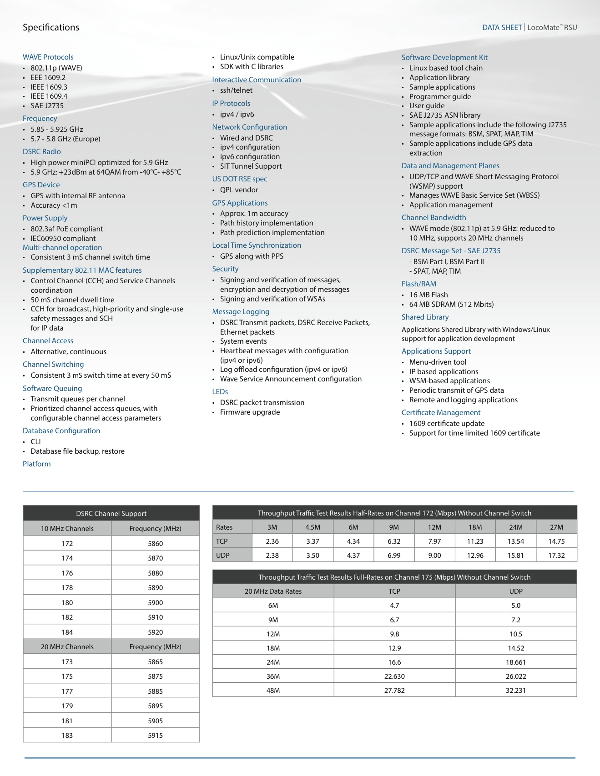

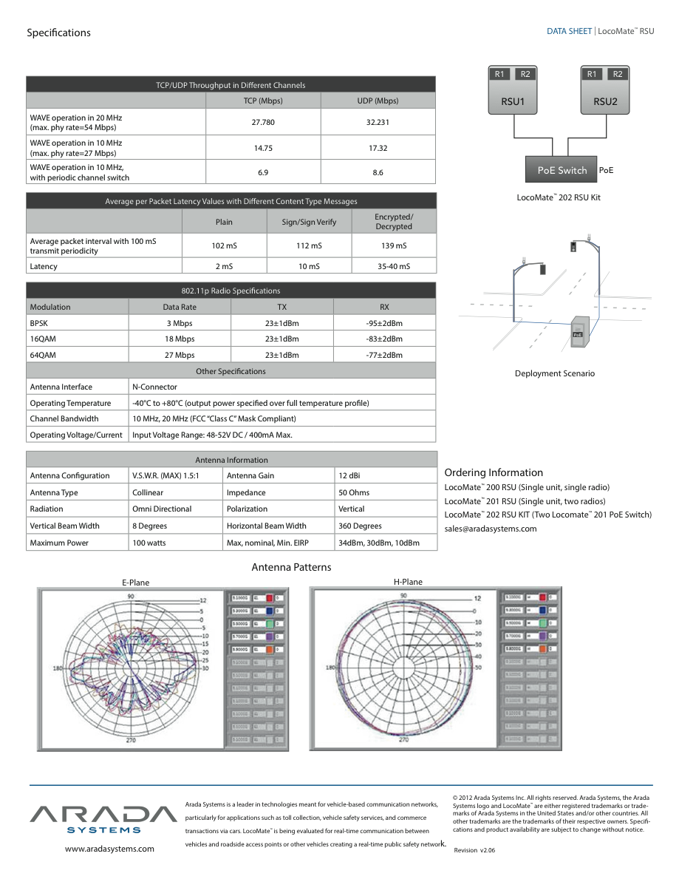

Appendix A: Savari OBE Product Specification Sheets

